Caitlan Nichols  
17 August 2024

Module 1.2 - GitHub Repository Setup

I have created my own way before this class and wished to try it out but I never could. Here is how I upload my own things and I will share the batch file to you in the assignment.  
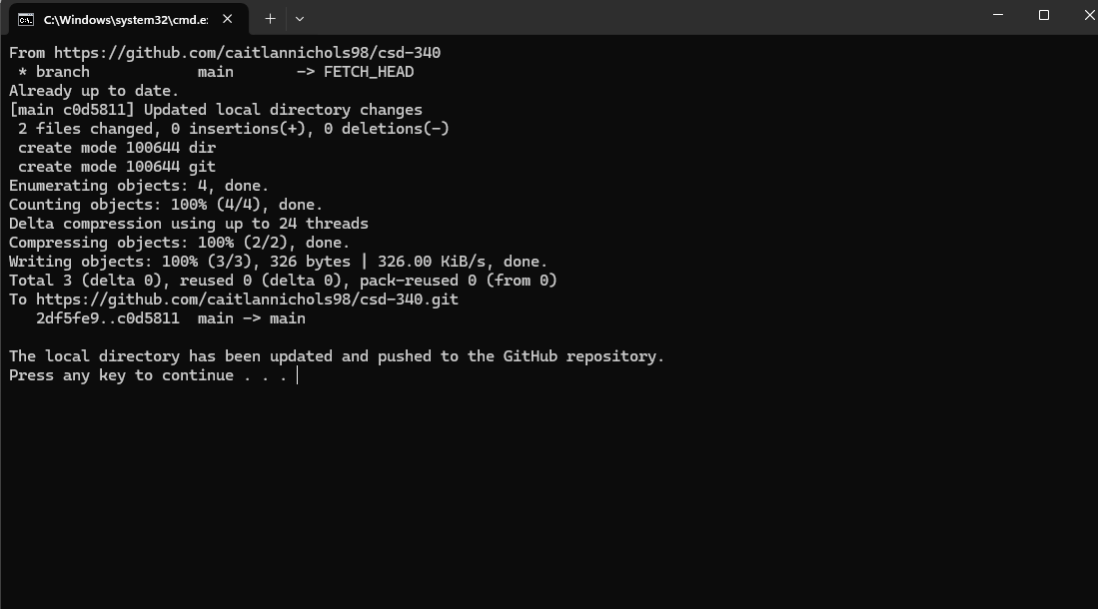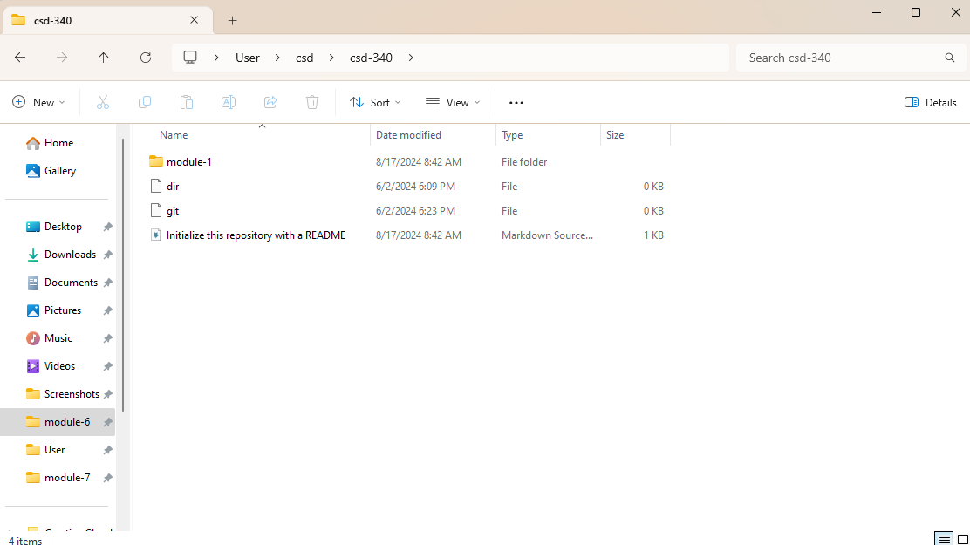<https://github.com/caitlannichols98/csd-340>   
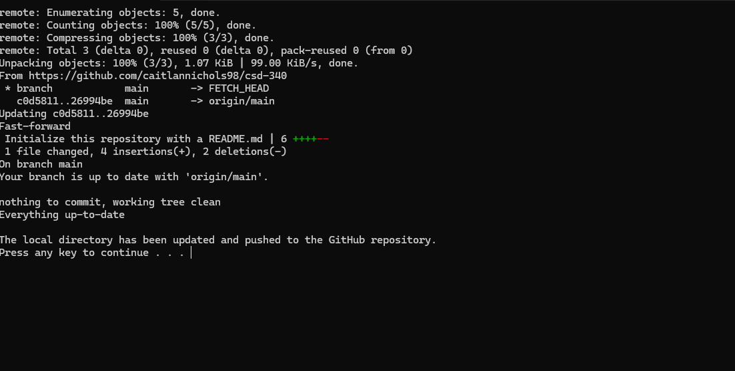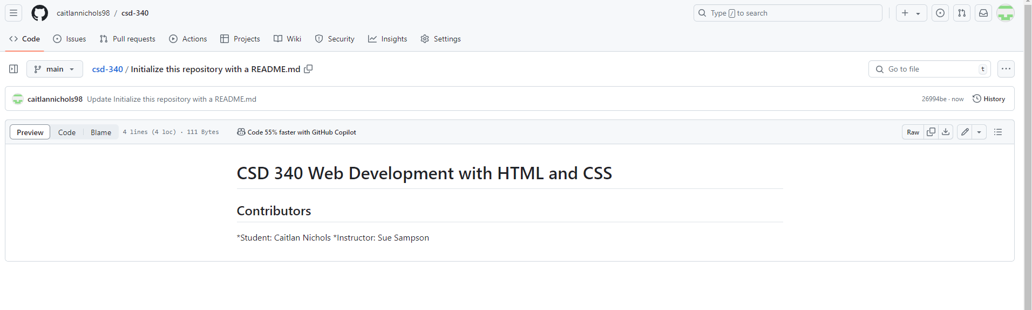

My batch code can allow me to work back and forth and both ends will be updated in real time without errors and glitches in my edits.